ANSWERS
Identify each figure as two-dimensional or three-dimensional.
1. |  | 2. |  | 3. | 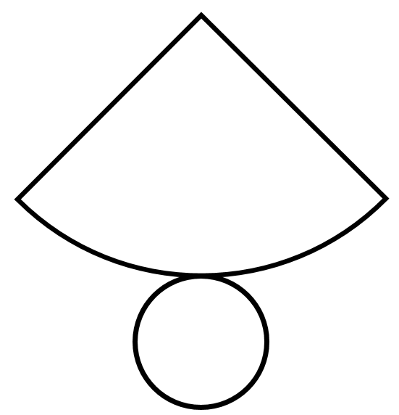
 | 2-D  Circle |  | 3-D  Prism |  | 3-D  Cone

Draw a net for each figure and then list what 2D shapes you would need to make each one.
4. |  | 5.
 | 2 squares  4 rectangles |  | 4 triangles  1 rectangle

Name a three-dimensional figure that can be formed from each net.
6. |  | 7.
 | Pentagonal Prism |  | Cone
8. | Triangular Prism | 9. | 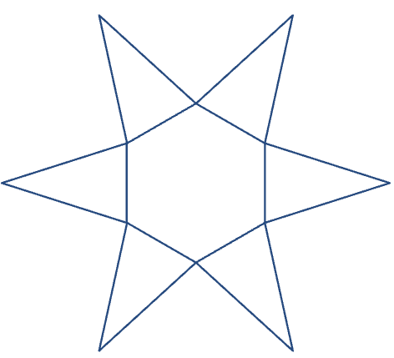  Hexagonal Pyramid
10. |  | 11.
 | Cylinder |  | Cube

Make an isometric drawing of each on isometric dot paper.
12. | 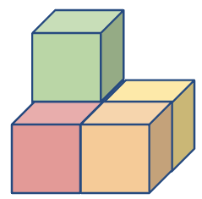 | 13. | 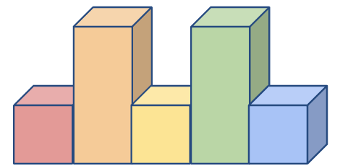
 | 
14. | 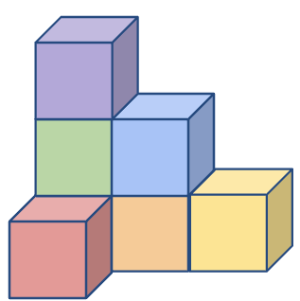 | 15. | 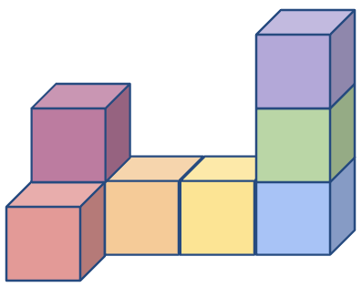

Make an orthographic drawing for each structure.
16. | 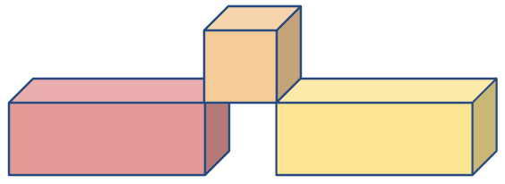 | 17. | 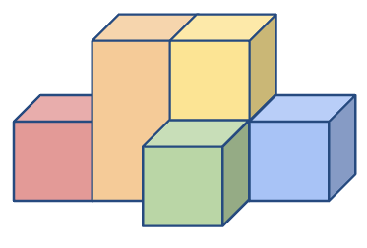
 | Top view  Front view  Right-side view |  | Top view  Front view  Right-side view

Use the orthographic drawing to make an isometric drawing of the structure.
18. | Top view Front view Right-side view | 19. | Top view Front view Right-side view
Use isometric dot paper to draw each.
20. | A triangular prism. The bases are right triangles with a height of 2 units and a base of 3 units. | 21. | A square prism that is 4 units high. The bases are squares with sides of 2 units.

