ANSWERS
Multiple choices
1. | Describe the slice resulting from a plane cutting a square pyramid at an angle perpendicular to the base.
 | a. Triangle | b. Square
 | c. Trapezoid | d. Circle

2. | How many faces does a triangular prism have?
 | a. 3 | b. 4
 | c. 5 | d. 6
3. Match each three-dimensional figure with its net.
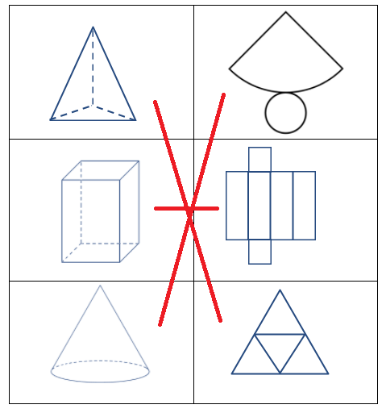

4. Use isometric dot paper to sketch a rectangular prism that is 3 units high. The bases are rectangles with 3 units’ length and 2 units’ width.


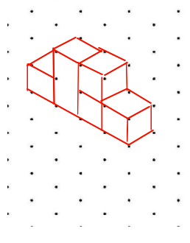
5. Make an isometric drawing.
