A net is a two-dimensional diagram that you can fold to form a three-dimensional figure.
A net shows all of the surfaces of a figure in one view.
Sample Problem 1: Identify each figure as two-dimensional or three-dimensional.
a. | 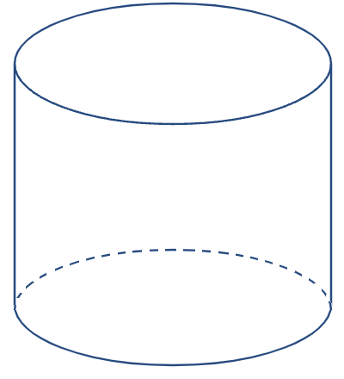 | b. |  | c.

Sample Problem 2: Draw a net for each figure and then list what 2D shapes you would need to make each one.
a. |  | b. |  | c.

Sample Problem 3: Name a three-dimensional figure that can be formed from each net.
a. |  | b.

An isometric drawing
An isometric drawing shows a corner view of a three-dimensional figure.
You can draw an isometric drawing on isometric dot paper.
Sample Problem 4: Make an isometric drawing of each cube structure on isometric dot paper.
a. | 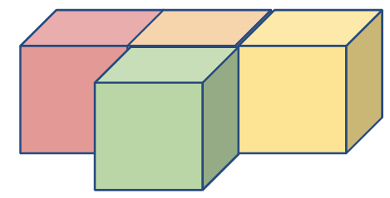 | b. | 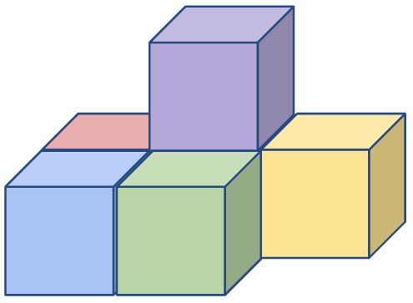
 | 

An orthographic drawing
An orthographic drawing is another way to represent a three-dimensional figure.
It shows a top view, front view, and right-side view.
Sample Problem 5: Make an orthographic drawing for each structure.
a. | 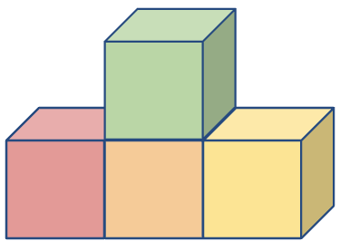 | b. | 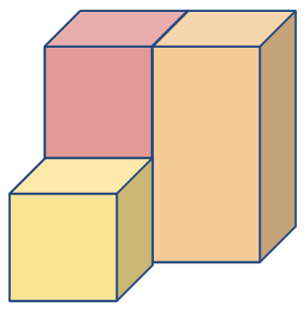
 | Top view  Front view  Right-side view |  | Top view  Front view  Right-side view

