**A net** is a two-dimensional diagram that you can fold to form a three-dimensional figure.

A net shows all of the surfaces of a figure in one view.

**Sample Problem 1**: Identify each figure as two-dimensional or three-dimensional.

|  |  |  |  |  |  |
| --- | --- | --- | --- | --- | --- |
| **a.** |  | **b.** |  | **c.** |  |
|  | 3-D  Cylinder |  | 3-D  Rectangular Prism |  | 2-D  Triangle |

**Sample Problem 2:** **Draw a net for each figure and then list what 2D shapes you would need to make each one.**

|  |  |  |  |  |  |
| --- | --- | --- | --- | --- | --- |
| **a.** |  | **b.** |  | **c.** |  |
|  |  |  |  |  |  |
|  | 6 squares |  | 2 circles and 1 rectangle |  | 4 triangles |

**Sample Problem 3:** Name a three-dimensional figure that can be formed from each net.

|  |  |  |  |
| --- | --- | --- | --- |
| **a.** |  | **b.** |  |
|  | Square Pyramid |  | Hexagonal Prism |

***An isometric drawing***

An isometric drawing shows a corner view of a three-dimensional figure.

You can draw an isometric drawing on isometric dot paper.

**Sample Problem 4:** **Make an isometric drawing of each cube structure on isometric dot paper.**

|  |  |  |  |
| --- | --- | --- | --- |
| **a.** |  | **b.** |  |

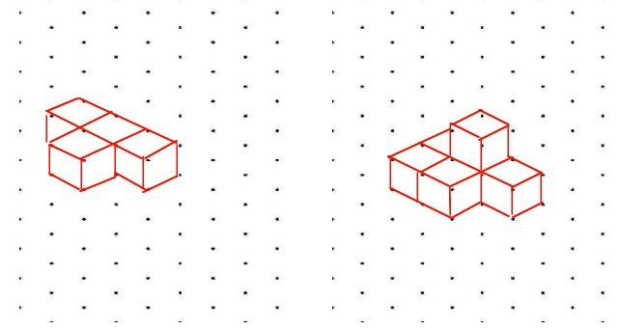

***An orthographic drawing***

An orthographic drawing is another way to represent a three-dimensional figure.

It shows a top view, front view, and right-side view.

**Sample Problem 5:** **Make an orthographic drawing for each structure.**

|  |  |  |  |
| --- | --- | --- | --- |
| **a.** |  | **b.** |  |
|  | Top view  Front view  Right-side view |  | Top view  Front view  Right-side view |