ANSWERS
Multiple choice
1. | If the coordinate of $H$ is $-6,$ and the coordinate $G$ is$25$ the length of segment $\overline{HG}$ is:
 | a. $-31$ | b. $31$
 | c. $-19$ | d. $19$

2. | If the coordinate of $T$ is $8$ and the coordinate of $Y$ is$-4,$ the coordinate of the midpoint of line segment$\overline{ TY}$ is:
 | a. $4$ | b. $2$
 | c. $-12$ | d. $- 4$

3. Find the value of $x$ and the length of each segment using a segment addition postulate.
 | Point $A$ is between points $G$ and $K.$  The points are collinear.  $$GA=x-5 AK=x-1 GK=10$$  $$\overline{GA}= ? \overline{AK}= ?$$ | $$G A K$$  $x-5 x-1.$ | $$GA +AK=GK$$  $$x-5+x-1=10$$  $$2x-6=10$$  $$2x-6+6=10+6$$  $$2x=16$$  $$x=8$$
 |  | $$GA=x-5$$  $$GA=8-5=3$$  $\overline{GA}=3$ | $$AK=x-1$$  $$AK=8-1=7$$  $$\overline{AK}=7$$

4. Find the length of the segment using the number line, and then find the coordinate of the midpoint of the segment.
$\overline{ZB}= ?$ $M_{\overline{ZB}}= ?$

$$Z M_{\overline{ZB}} B$$
0
1
2
3
4
-1
-2
-3
-4
5
6
-5
-6
$$ZB=\left|-3-4\right|= \left|-7\right|=7$$
$$\overline{ZB}=7$$
$$M_{\overline{ZB}}=\frac{-3+4}{2}=\frac{1 }{2}$$
$$M_{\overline{ZB}}=0.5$$

5. | On a number line, the coordinates of $E, R, T,and P$ are $-7, -2, 0 and 5$, respectively.  Find the lengths of $\overline{ER}, \overline{RP }and \overline{TP }$. Determine which segments are congruent.  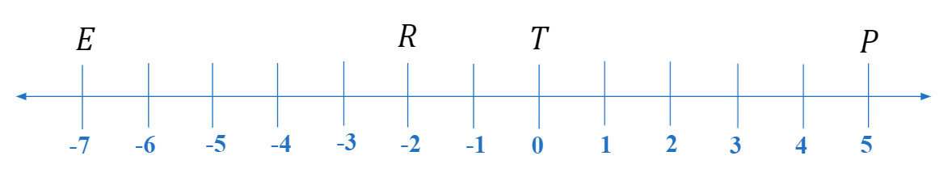
$$ER=\left|-7-(-2)\right|= \left|-7+2\right|=\left|-5\right|=5$$
$$RP=\left|-2-5\right|= \left|-7\right|=7$$
$$TP=\left|0-5\right|= \left|-5\right|=5$$
$$ER=TP$$
$\overline{ER}≅\overline{TP}$

