Multiple choice
1. | Find the value of $x$ in the figure below.  $$x$$  $$48°$$
 | a. $42°$ | b. $132°$
 | c. $32°$ | d. $90°$

2. | Which of the following statements is true?  $R F$  $A$  $S D$
 | a. $∠DSA and∠DSF$are obtuse angles | b. $∠DSF and∠RSA$are acute angles
 | c. $∠FSA and∠DSR$are obtuse angles | d. $∠RSA and∠DSR$are acute angles

3. Find the measure of each angle.
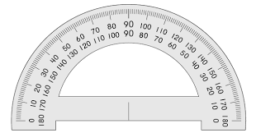
$m∠ENH,m∠YNH, m∠HNR =?$
$R H$
$$Y$$

$$D N E$$

4. Find the value of $x$ and then the indicated angle measures.
If $m∠UFP=9x+30$, $m∠PFT=x+10,$
what are $m∠UFP and m∠PFT?$
$$P$$

$$\left(x+10\right)° \left(9x+30\right)°$$

$T F U$

5. Find the indicated angle measures.
If $\vec{AN}$bisects$∠BAT$ and $m∠BAT=126$ , find $m∠BAH$ and $m∠BAH.$

$T H$

$A B$

