

**Algebra 1**

UNIT 1 – Interactive Notebook

**1-3 Simplifying Numerical Expressions (Order of Operations)**

|  |  |  |  |
| --- | --- | --- | --- |
| **Name:** |  | **Date:** |  |

|  |  |
| --- | --- |
| **Common Core Standards** | [CCSS.MATH.CONTENT.HSA.SSE.B.3](http://www.corestandards.org/Math/Content/HSA/SSE/B/3/) Choose and produce an equivalent form of an expression to reveal and explain properties of the quantity represented by the expression.* |

**SIMPLIFYING NUMERICAL EXPRESSIONS**

In Mathematics, to simplify means to make something its simplest form. For example:

$\left(-6\right)+\left(-5\right)+8$**can be simplified as $-3$**

**ORDER OF OPERATIONS**

**EXPRESSIONS INVOLVING THE FOUR OPERATIONS**

****Expressions involving addition, subtraction, multiplication and division, follows the **MDAS** rule.

* First, do all multiplications and/or divisions, whichever comes first, from left to right.
* Then, do all additions and/or subtractions, whichever comes first, from left to right.

**Example 1: $\left(-8\right)+10÷\left(-2\right)-5×4$**

$$\left(-8\right)+10÷\left(-2\right)-5×4$$

$$\left(-8\right)+(-5)-5×4$$

$\left(-8\right)+\left(-5\right)$ $-20$

$-13-20$

$$-33$$

**Example 2: $\left(-6\right)\left(3\right)÷9-10-(-12)$**

$\left(-6\right)\left(3\right)$ $÷9-10-(-12)$

$-18÷9$ $-10-(-12)$

$-2-10$ $–(-12)$

$$-12-(-12)$$

$$-12+12$$

$$0$$

**EXPRESSIONS INVOLVING PARENTHESES, BRACKETS AND THE FOUR OPERATIONS**

****Expressions involving parentheses, brackets, braces, addition, subtraction, multiplication and division, follows the **PMDAS** rule.

* First, remove grouping symbols like **( )**, **[ ]**, **{ }** by working on operations from the innermost part. Start with operations inside the parentheses, followed by the operations inside the brackets and then the operations inside the braces. These symbols disappear when you perform the all the operations (still following the MDAS rule) inside them.
* Then, do all multiplications and/or divisions, whichever comes first, from left to right.
* Lastly, do additions and/or subtractions, whichever comes first, from left to right.

**Example 1: $-10\left[16÷\left(-4\right)+3\right]-4$**

$$-10\left[16÷\left(-4\right)+3\right]-4$$

$$-10\left[-4+3\right]-4$$

$-10\left[-1\right]$ $-4$

$$10-4$$

$$6$$

**Example 2: $\left[\left(9-3\right)÷2\left(-3\right)\right]-[5+\left(3\right)\left(-2\right)]$**

$$\left[\left(9-3\right)÷2\left(-3\right)\right]-\left[5+\left(3\right)\left(-2\right)\right]$$

$$\left[6÷2\left(-3\right)\right]-[5+(-6)]$$

$$\left[3\left(-3\right)\right]-[-1]$$

$$\left[-9\right]-[-1]$$

$$-9+1$$

$$-8$$

**EXPRESSIONS INVOLVING THE FOUR OPERATIONS AND EXPONENTS**

Expressions involving exponents, addition, subtraction, multiplication and division, follows the **EMDAS** rule.



* First, simplify the numbers with exponents. Make sure that all numbers raised to a certain power are calculated.
* Then, do all multiplications and/or divisions, whichever comes first, from left to right.
* Lastly, do all additions and/or subtractions, whichever comes first, from left to right.

**Example 1: $5^{2}÷5+\left(-5\right)\left(5\right)-5$**

$5^{2}$ $÷5+\left(-5\right)\left(5\right)-5^{2}$

$25÷5$ $+\left(-5\right)\left(5\right)-25$

$5$ $+\left(-5\right)\left(5\right)-25$

$5$ $+(-25)$ $-25$

$-20-25$

$$-45$$

**Example 2: $12-({-2)}^{4}÷\left(-16\right)+3^{2}-{(-1)}^{3}$**

$$12-({-2)}^{4}÷\left(-16\right)+3^{2}-{(-1)}^{3}$$

$$12-16÷\left(-16\right)+9-(-1)$$

$12-(-1)$ $+9-(-1)$

$13+9$ $-(-1)$

$$22-(-1)$$

$$23$$

**EXPRESSIONS INVOLVING PARENTHESES, EXPONENTS AND THE FOUR OPERATIONS**

****Expressions involving parentheses, brackets, addition, subtraction, multiplication and division, follows the **PMDAS** rule.

* First, remove grouping symbols like **( )**, **[ ]**, **{ }** by working on operations from the innermost part. Start with operations inside the parentheses, followed by the operations inside the brackets and then the operations inside the braces. These symbols disappear when you perform the all the operations (still following the MDAS rule) inside them.
* Next, simplify the numbers with exponents. Make sure that all numbers raised to a certain power are calculated.
* Then, do all multiplications and/or divisions, whichever comes first, from left to right.
* Lastly, do additions and/or subtractions, whichever comes first, from left to right.

**Example 1: $(45+7)÷(12÷3)+3^{2}$**

$(45+7)$ $÷(12÷3)+3^{2}$

$52$ $÷4+3^{2}$

$52$ $÷4$ $+9$

$13+9$

**22**

**Example 2: ${\left[\left(75-26\right)÷7\right]}^{2}+[{\left(-2\right)}^{2}\left(84÷12\right)]$**

$${\left[\left(75-26\right)÷7\right]}^{2}+[{\left(-2\right)}^{2}\left(84÷12\right)]$$

$${\left[49÷7\right]}^{2}+[{\left(-2\right)}^{2}\left(7\right)]$$

$${[7]}^{2}+[(4)(7)]$$

$$49+28$$

$$77$$

**The Order is Right!**

The solution in simplifying the expression

${(8-10)}^{2}\left[24÷\left(6-2\right)\right]+5$ is shown below. Describe the process used in each step.

**Solution**

$${(8-10)}^{2}\left[24÷\left(2-6\right)\right]+5$$

$${(-2)}^{2}\left[24÷\left(-4\right)\right]+5$$

$${(-2)}^{2}\left[-6\right]+5$$

$$4\left[-6\right]+5$$

$$-24+5$$

$$-19$$

**1.**

**2.**

**3.**

**4.**

**5.**

Was the expression simplified correctly? ______________

Justify your answer: ____________________________

**Make it Simple!**

Simplify the expression below:

$$-5[{\left(6÷3\right)}^{2}+9-3]$$

**Task Cards**

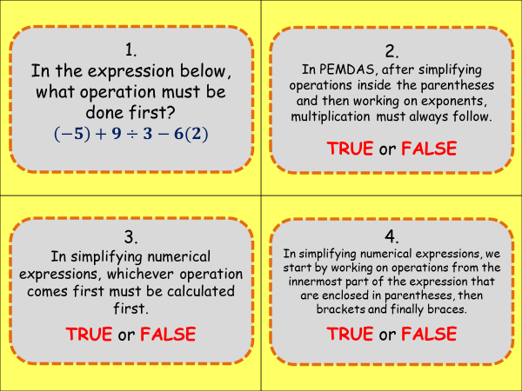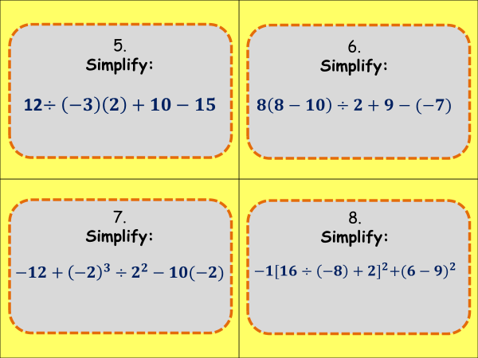

Answers:

**The Order is Right!**

1. Subtract numbers inside the parentheses
2. Divide the numbers inside the brackets
3. Simplify the number with exponent
4. Multiply
5. Add

Yes, because it follows the correct order of operations.

**Make It Simple!**

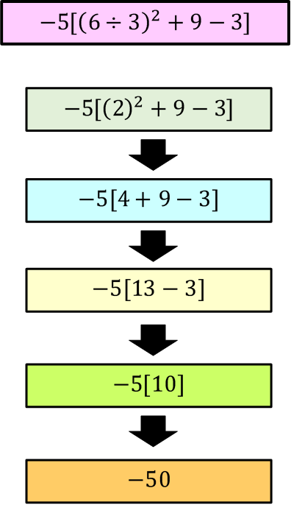

**Task Cards**

1. **DIVIDE**
2. **FALSE**
3. **FALSE**
4. **TRUE**
5. **12 $÷\left(-3\right)\left(2\right)+10-15$**

$$(-4)\left(2\right)+10-15$$

$$-8+10-15$$

$$2-15$$

$$-13$$

$8\left(8-10\right)÷2+9-(-7)$

$$8\left(-2\right)÷2+9-(-7)$$

$$-16÷2+9-(-7)$$

$$-8+9-(-7)$$

$$1-(-7)$$

$$8$$

$-12+{\left(-2\right)}^{3}÷2^{2}-10\left(-2\right)$

$$-12+(-8)÷4-10(-2)$$

$$-12+(-2)-10(-2)$$

$$-12+(-2)-(-20)$$

$$-14-(-20)$$

$$6$$

$-1{[16÷\left(-8\right)+2]}^{2}+{(6-9)}^{2}$

$$-1{[-2+2]}^{2}+{(-3)}^{2}$$

$$-1{[0]}^{2}+{(-3)}^{2}$$

$$-1[0]+9$$

$$0+9$$

$$9$$