

**Algebra 1**

UNIT 1 – Interactive Notebook

**1-4 Rational Numbers**

|  |  |  |  |
| --- | --- | --- | --- |
| **Name:** |  | **Date:** |  |

|  |  |
| --- | --- |
| **Common Core Standards** | [CCSS.MATH.CONTENT.8.NS.A.1](http://www.corestandards.org/Math/Content/8/NS/A/1/) Know that numbers that are not rational are called irrational. Understand informally that every number has a decimal expansion; for rational numbers show that the decimal expansion repeats eventually, and convert a decimal expansion which repeats eventually into a rational number.  [CCSS.MATH.CONTENT.HSA.SSE.B.3](http://www.corestandards.org/Math/Content/HSA/SSE/B/3/) Choose and produce an equivalent form of an expression to reveal and explain properties of the quantity represented by the expression.* |

**RATIONAL NUMBERS**

**Rational Numbers** are numbers that can be written in the form:

$\frac{a}{b}$ where $a$ and $b$ are integers, and $b$ is not equal to **0 $(b≠0)$**

It is very important to remember that dividing a number by zero is not allowed as the answer is **undefined**.

$$\frac{5}{0}=undefined$$

***Integers are rational numbers. Every integer can be written in the form $\frac{a}{b}$:***

**Examples:**



***Non-integers can be rational numbers too. Some of them can also be written in the form $\frac{a}{b}$:***

**Examples:**



***When rational numbers expressed as fractions are divided, the quotient can be a terminating or repeating decimal number.***

A **terminating decimal number** is one that has a finite number of digits. This means that the digits end.



A **repeating decimal number** is one that has digits that repeats and never ends.



**IRRATIONAL NUMBERS**

On the other hand, there are numbers that are not rational. They are called **irrational numbers**. Unlike rational numbers, irrational numbers when expressed in decimal form can be a **non-terminating** and **non-repeating**.

A **non-terminating** and **non-repeating** decimal number has digits that don’t repeat and goes on and on without end.

**Examples:**

$\sqrt{2}$**can’t be written in the form $\frac{a}{b}$.**

$\sqrt{5}$**can’t be written in the form $\frac{a}{b}$.**

$\sqrt{7}$**can’t be written in the form $\frac{a}{b}$.**



**CHANGING FRACTIONS TO DECIMALS**

As mentioned earlier, **rational numbers can be in fraction or decimal form**. These forms are equivalent and can be transformed into one form or another. Changing fractions into its decimal form is like doing a simple division.

The required step is very simple: **Divide the numerator by the denominator.**

**Example 1:**



In the examples above, the rational numbers expressed as decimal numbers are **terminating decimals**.

**Example 2:**



In the examples above, the rational numbers expressed as decimal numbers are **repeating and non-terminating decimals**. These types of decimals repeat over and over again, without end.

***Repeating*** *and* ***non-terminating decimal numbers*** *can be written in two different ways:*

**CHANGING TERMINATING DECIMALS TO FRACTIONS**

Let’s now reverse the process. This time, we’ll transform terminating decimals to its equivalent fraction. In changing decimal numbers to fractions, we use its digits (without the decimal point) as the numerator. The denominator on the other hand must be a power of 10.

We need to select the appropriate denominator such as 10, 100, 1 000, 10 000, and so on. Don’t forget to always change the fraction in its lowest term, if possible.

**Examples:**



**CHANGING REPEATING AND NON-TERMINATING DECIMALS TO FRACTIONS**

While changing terminating decimal numbers to fractions is a piece of cake, doing the same for repeating and non-terminating decimal numbers is a different story. But there is nothing to worry about. The steps on how to do it are explained clearly in the examples below.

**Example 1:** Change **0.888…** to its fraction form.

**Step 1:** Let’s create an equation by choosing any variable. We could let $x$ be equal to the given repeating and non-terminating decimal number.

$$x=0.888…$$

**Step 2:** Examine the repeating decimal closely to determine the number of digit or digits that repeats.

$$x=0.888…$$

There is only one repeating digit, 8.

**Step 3:** Using the original equation, we need to place the repeating digit to the left of the decimal point. Since we only have one repeating digit, we’ll multiply both sides of the original equation by 10.

$$\left(10\right)x=0.888…(10)$$

$$10x=8.888…$$

**Step 4:** Subtract the two equations.

$$10x=8.888…$$

$x=0.888…$

$9x=8$

**Step 5:** Solve for $x$ by dividing both sides by 9.

$$\frac{9x}{9}=\frac{8}{9}$$

$$x=\frac{8}{9}$$

So, $0.888…=\frac{8}{9}$.

We can’t simplify $\frac{8}{9}$ any further.

Let’s confirm if we are correct.



Or better yet, you may use a calculator to confirm.

**Rational vs Irrational**

Color the boxes ORANGE if the number is rational and YELLOW if irrational.

3.75

0.2…

$$0.\overline{123}$$

$$\sqrt{9}$$

$$\frac{1}{3}$$

-10

$$\sqrt{-4}$$

0

$$π$$

$$\frac{0}{100}$$

$$-25$$

$$-\sqrt{4}$$

**Classify**

Place the following rational numbers according to their appropriate category.

|  |  |  |  |  |
| --- | --- | --- | --- | --- |
|  |  |  |  |  |
|  |  |  |  |  |

|  |
| --- |
| **Whole Number** |
| **Terminating Decimal** |
| **Non-Terminating Decimal** |
| **Repeating Decimal** |
| **Non-repeating Decimal** |

**Task Cards**

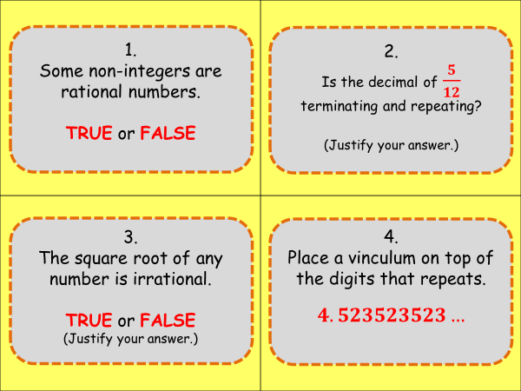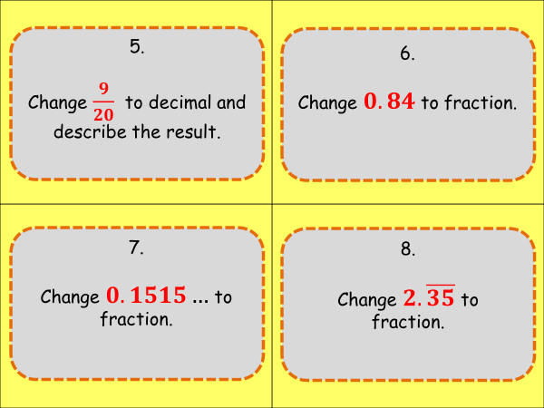

Answers:

**Rational vs Irrational**

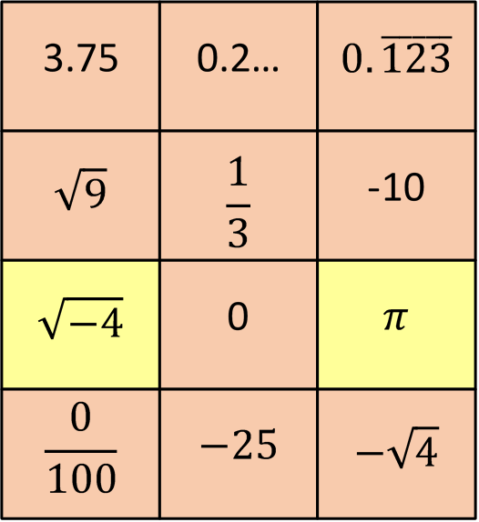

**Classify**

**Whole Number: $\frac{12}{4}, \frac{221}{13}$**

**Terminating Decimal: $0.45, 0.65, \frac{21}{16}, \frac{17}{40}, \frac{1}{1000}$**

**Non-terminating Decimal: $\frac{2}{3}, 0.75…, 3.\overline{125}$**

**Repeating Decimal: $\frac{2}{3}, 0.75…, 3.\overline{125}$**

**Non-repeating Decimal: $0.45, 0.65, \frac{21}{16}, \frac{17}{40}, \frac{1}{1000}$**

**Task Cards**

1. **TRUE**
2. **It is a non-terminating and repeating decimal number: $0.41\overline{6}$.**
3. **FALSE**
$4.\overline{523}$

4. $\frac{9}{20}=0.45$**, the decimal number is terminating.**

$0.1515…$

$$x=0.1515…$$

$$100x=15.1515…$$

$x=0.1515…$

$$99x-15$$

$$\frac{99x}{99}=\frac{15}{99}$$

$$x=\frac{15}{99} or \frac{5}{33}$$

$$0.1515…=\frac{5}{33}$$

$0.84=\frac{84}{100} or \frac{21}{25}$

$2.\overline{35}$

$$x=2.\overline{35}$$

$$100x=235.\overline{35}$$

$$x=2.\overline{35}$$

$$99x=233$$

$$\frac{99x}{99}=\frac{233}{99}$$

$$x=\frac{233}{99}$$

$$2.\overline{35}=\frac{233}{99} or 2\frac{35}{99}$$