**Rational Numbers**

**Directions: Answer each question. Use your answer to navigate through the maze. Show your work.**

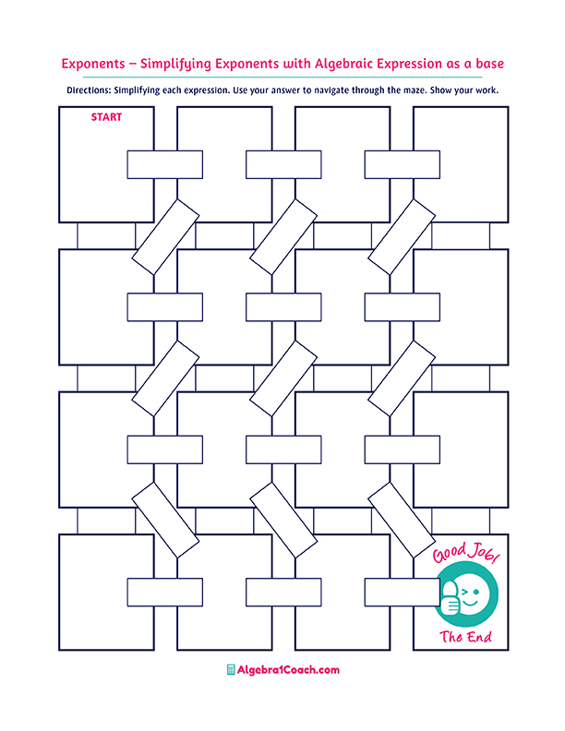

**Identify the**

**irrational number!**

**Identify the irrational number!**

**Identify the rational number!**

$$2\frac{2}{5}$$

**Which of the following numbers is a whole number?**

**Which of the following numbers is rational?**

$-2.4$**as a fraction is:**

$$1.8$$

$$1.7$$

$$0.2$$

$$-2\frac{1}{5}$$

$$1.3535……$$

$$\sqrt{36}$$

$4$**as a fraction is:**

$12$**as a fraction is:**

**Which of the following numbers is rational?**

**Which of the following numbers is a whole number?**

$$\frac{2}{24}$$

$$\frac{24}{2}$$

$$2.3333..$$

**Which of the following numbers is irrational?**

**Which of the following numbers is an integer?**

$$0.25$$

$$\frac{15}{3}$$

$$\frac{6}{4}$$

**It is a rational and an integer.**

$\frac{4}{16}$**as a decimal is:**

$$\sqrt{64}$$

$$-\sqrt{9}$$

$$1.\overline{3}$$

$$π$$

$$-3$$

$\frac{4}{3}$**as a decimal is:**

$$\sqrt{13}$$

$$\sqrt{5}$$

$$\sqrt{25}$$

$$-8.\overline{4}$$

$$\sqrt{144}$$

$$-\sqrt{4}$$

$$0.\overline{6}$$

$$\sqrt[3]{4}$$

$$\sqrt{13}$$

$$\frac{16}{4}$$

$$2.\overline{1}$$

$$\sqrt{7}$$

$$\sqrt{24}$$

$$\sqrt{3}$$

$$0.\overline{25}$$