Name: _____________________________ Period: _______________ Date: ____________

**Multiplication Using Array Model** Assignment **Math 3**

**Part A:**

Trace the table to identify the expression of the array model. Color the table with the corresponding color to its product.

|  |  |
| --- | --- |
|  |  |
|  |  |
|  |  |
|  |  |
|  |  |
|  |  |

|  |  |  |  |
| --- | --- | --- | --- |
|  |  |  |  |
|  |  |  |  |
|  |  |  |  |
|  |  |  |  |
|  |  |  |  |  |
|  |  |  |  |  |
|  |  |  |  |  |

_______________ _______________ _______________

|  |  |  |  |  |  |  |  |
| --- | --- | --- | --- | --- | --- | --- | --- |
|  |  |  |  |  |  |  |  |
|  |  |  |  |  |  |  |  |
|  |  |  |  |  |  |  |  |

Copyright © MathTeacherCoach.com 1

Name: _____________________________ Period: _______________ Date: ____________

**Multiplication Using Array Model** Assignment **Math 3**

|  |  |  |  |  |  |  |  |
| --- | --- | --- | --- | --- | --- | --- | --- |
|  |  |  |  |  |  |  |  |
|  |  |  |  |  |  |  |  |
|  |  |  |  |  |  |  |  |
|  |  |  |  |  |  |  |  |
|  |  |  |  |  |
|  |  |  |  |  |
|  |  |  |  |  |
|  |  |  |  |  |
|  |  |  |  |  |
|  |  |  |  |  |
|  |  |  |  |  |
|  |  |  |  |  |
|  |  |  |  |  |

|  |  |  |  |  |  |
| --- | --- | --- | --- | --- | --- |
|  |  |  |  |  |  |
|  |  |  |  |  |  |
|  |  |  |  |  |  |
|  |  |  |  |  |  |
|  |  |  |  |  |  |
|  |  |  |  |  |  |
|  |  |  |  |  |  |
|  |  |  |  |  |  |

_______________ _______________ _______________

**Orange = 12 | Yellow = 48 | Blue = 45 | Green = 15 | Purple = 16 | Red = 56**

Copyright © MathTeacherCoach.com 2

Name: _____________________________ Period: _______________ Date: ____________

**Multiplication Using Array Model** Assignment **Math 3**

**Part B:**

Identify how many rows and columns there are in each array model. Write their corresponding expressions.

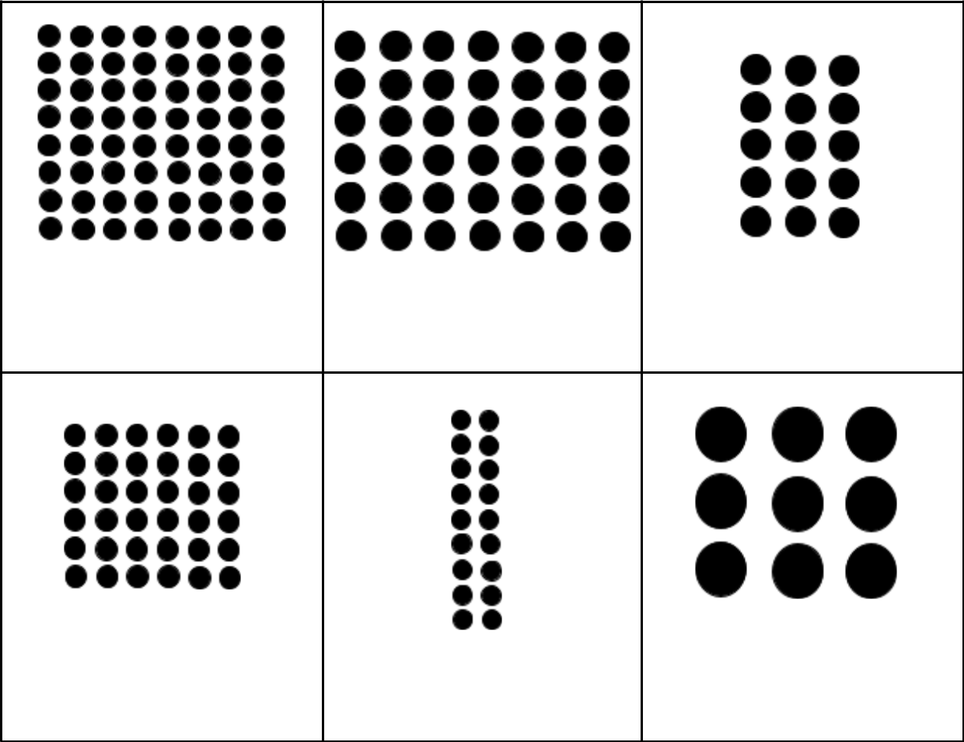

|  |  |  |
| --- | --- | --- |
| Rows: | Rows: | Rows: |
| Columns: | Columns: | Columns: |
| Expression: | Expression: | Expression: |

|  |  |  |
| --- | --- | --- |
| Rows: | Rows: | Rows: |
| Columns: | Columns: | Columns: |
| Expression: | Expression: | Expression: |

Copyright © MathTeacherCoach.com 3

Name: _____________________________ Period: _______________ Date: ____________

**Multiplication Using Array Model** Assignment **Math 3**

|  |  |  |
| --- | --- | --- |
| Rows: | Rows: | Rows: |
| Columns: | Columns: | Columns: |
| Expression: | Expression: | Expression: |
|  |  |  |

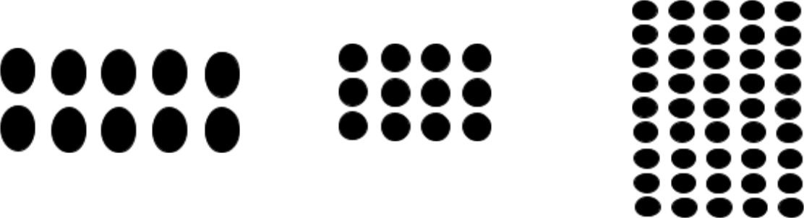

**Part C:**

Draw the following equations into an array model and determine the product.

1. 4 x 6 =

2. 6 x 3 =

3. 7 x 5 =

Copyright © MathTeacherCoach.com 4

Name: _____________________________ Period: _______________ Date: ____________

**Multiplication Using Array Model** Assignment **Math 3**

4. 5 x 4 =

**Part D:**

Answer the following word problems by solving using array models.

1. Jack likes to play with marbles. He has 5 rows of 5 marbles. How many marbles does he have?
2. Cathy wants to buy candy worth 50 coins. She has 4 by 8 coins. Will she be able to buy the candy?

Copyright © MathTeacherCoach.com 5

Name: _____________________________ Period: _______________ Date: ____________

**Multiplication Using Array Model** Assignment **Math 3**

1. Tiffany has rings. She aligned them into 3 rows and 9 columns. How many rings does she have?

Copyright © MathTeacherCoach.com 6