Name: _____________________________ Period: _______________ Date: ____________

**Multiplication Using Array Model** Assignment–Teacher Edition**Math 3**

**Part A:**

Trace the table to identify the expression of the array model. Color the table with the corresponding color to its product.

|  |  |
| --- | --- |
|  |  |
|  |  |
|  |  |
|  |  |
|  |  |
|  |  |

|  |  |  |  |
| --- | --- | --- | --- |
|  |  |  |  |
|  |  |  |  |
|  |  |  |  |
|  |  |  |  |
|  |  |  |  |  |
|  |  |  |  |  |
|  |  |  |  |  |

4 x 4 3 x 5 6 x 2

|  |  |  |  |  |  |  |  |
| --- | --- | --- | --- | --- | --- | --- | --- |
|  |  |  |  |  |  |  |  |
|  |  |  |  |  |  |  |  |
|  |  |  |  |  |  |  |  |

Copyright © MathTeacherCoach.com 1

Name: _____________________________ Period: _______________ Date: ____________

**Multiplication Using Array Model** Assignment–Teacher Edition**Math 3**

|  |  |  |  |  |  |  |  |
| --- | --- | --- | --- | --- | --- | --- | --- |
|  |  |  |  |  |  |  |  |
|  |  |  |  |  |  |  |  |
|  |  |  |  |  |  |  |  |
|  |  |  |  |  |  |  |  |
|  |  |  |  |  |
|  |  |  |  |  |
|  |  |  |  |  |
|  |  |  |  |  |
|  |  |  |  |  |
|  |  |  |  |  |
|  |  |  |  |  |
|  |  |  |  |  |
|  |  |  |  |  |

|  |  |  |  |  |  |
| --- | --- | --- | --- | --- | --- |
|  |  |  |  |  |  |
|  |  |  |  |  |  |
|  |  |  |  |  |  |
|  |  |  |  |  |  |
|  |  |  |  |  |  |
|  |  |  |  |  |  |
|  |  |  |  |  |  |
|  |  |  |  |  |  |

8 x 6 7 x 8 9 x 5

**Orange = 12 | Yellow = 48 | Blue = 45 | Green = 15 | Purple = 16 | Red = 56**

Copyright © MathTeacherCoach.com 2

Name: _____________________________ Period: _______________ Date: ____________

**Multiplication Using Array Model** Assignment–Teacher Edition**Math 3**

**Part B:**

Identify how many rows and columns there are in each array model. Write their corresponding expressions.

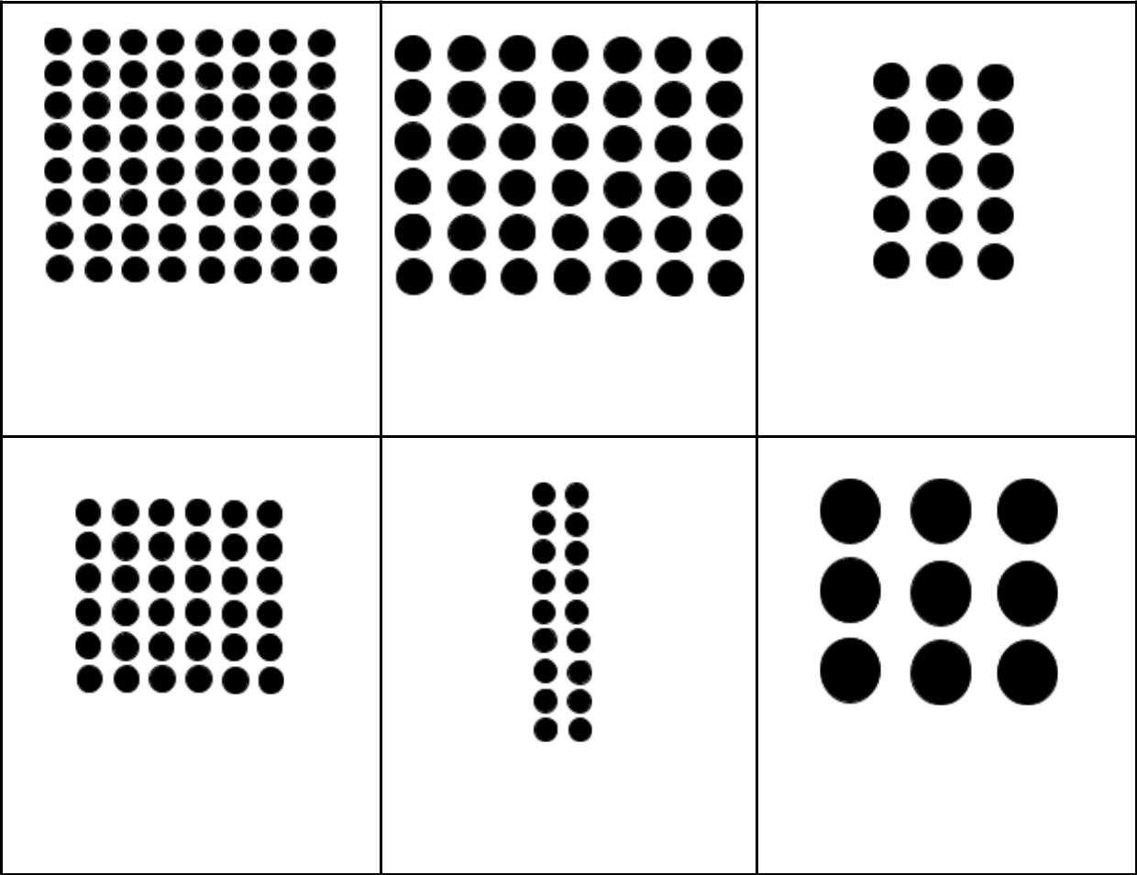

|  |  |  |
| --- | --- | --- |
| Rows: 8 | Rows: 6 | Rows: 5 |
| Columns: 8 | Columns: 7 | Columns: 3 |
| Expression: 8 x 8 | Expression: 6 x 7 | Expression: 5 x 3 |

|  |  |  |
| --- | --- | --- |
| Rows: 6 | Rows: 9 | Rows: 3 |
| Columns: 6 | Columns: 2 | Columns: 3 |
| Expression: 6 x 6 | Expression: 9 x 2 | Expression: 3 x 3 |

Copyright © MathTeacherCoach.com 3

Name: _____________________________ Period: _______________ Date: ____________

**Multiplication Using Array Model** Assignment–Teacher Edition**Math 3**

|  |  |  |
| --- | --- | --- |
| Rows: 2 | Rows: 3 | Rows: 9 |
| Columns: 5 | Columns: 4 | Columns: 5 |
| Expression: 2 x 5 | Expression: 3 x 4 | Expression: 9 x 5 |
|  |  |  |

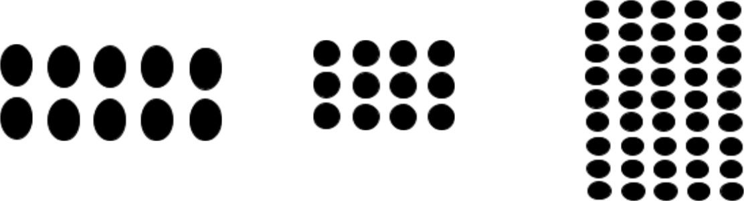

**Part C:**

Draw the following equations into an array model and determine the product.



1. 4 x 6 = 24



2. 6 x 3 = 18



3. 7 x 5 = 35

Copyright © MathTeacherCoach.com 4

Name: _____________________________ Period: _______________ Date: ____________

**Multiplication Using Array Model** Assignment–Teacher Edition**Math 3**

4. 5 x 4 = 20



**Part D:**

Answer the following word problems by solving using array models.

1. Jack likes to play with marbles. He has 5 rows of 5 marbles. How many marbles does he have?

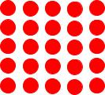

* + 25 marbles

1. Cathy wants to buy candy. She has 4 by 8 coins. How many coins does she have?



= 32 coins

Copyright © MathTeacherCoach.com 5

Name: _____________________________ Period: _______________ Date: ____________

**Multiplication Using Array Model** Assignment–Teacher Edition**Math 3**

1. Tiffany has rings. She aligned them into 3 rows and 9 columns. How many rings does she have?



= 27 rings

Copyright © MathTeacherCoach.com 6