Name: _____________________________ Period: _______________ Date: ____________

**Multiplication Using Array Model** Guided Notes **Math 3**

**What is an array?**

Using an array model is one way to multiply factors visually. Factors are what we call the numbers that we multiply. Multiplying using an array model means drawing a particular number of same-sized objects into **rows and columns**. An array model is an image where you can count horizontal rows and vertical columns. The factors are the numbers that determine

**how many rows of particular columns there will be**.

That means that **each row always has the same amount of** **items in it**. The total number of items in an array model is whatwe call the product, which is the answer to a multiplication problem.

We can read a multiplication equation **A x B** as **A rows having B** **columns**.

For example, **3 x 6** can be read as having **3 rows of 6 columns**. With this, we will draw 6 same-sized shapes into one horizontal straight line. Then, we repeat it until we have 3 rows.

Count how many items there are in the array to determine the product.

Copyright © MathTeacherCoach.com 1

Name: _____________________________ Period: _______________ Date: ____________

**Multiplication Using Array Model** Guided Notes **Math 3**

For example:

**3 x** **6**



**3 rows** **of 6**

First, draw 6 same-size shapes in one horizontal line:



Then, draw a horizontal line with the same amount of circles until you reach the desired number of rows:

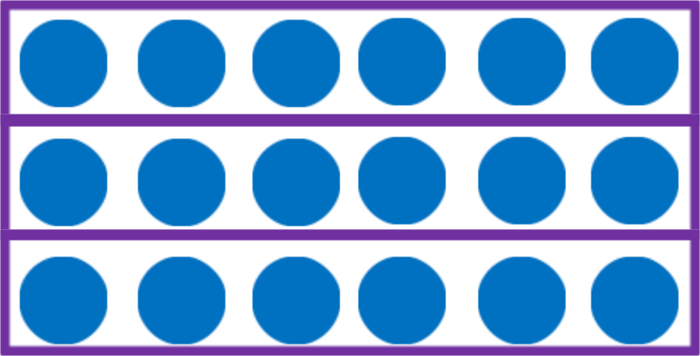

Count all the dots created in the 3 by 6 array model:

There are **18** dots in the array model.

So, the product is **18**.

Copyright © MathTeacherCoach.com 2

Name: _____________________________ Period: _______________ Date: ____________

**Multiplication Using Array Model** Guided Notes **Math 3**

Encircle the model that shows an array



How many rows and how many columns does the array have?

**Time to think**

1. What does an array model look like? How does it help in multiplication?
2. Why can’t scattered items be classified as arrays?
3. Is a table an array?

Copyright © MathTeacherCoach.com 3

Name: _____________________________ Period: _______________ Date: ____________

**Multiplication Using Array Model** Guided Notes **Math 3**

An array can actually be composed of more than one array.

See the array below:

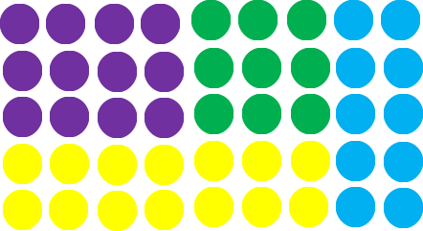

The purple array is composed of _____ rows and _____

columns.

Its expression can be written as _____ x _____

The yellow array is composed of _____ rows and _____

columns.

The expression can be written as _____ x _____

The green array is composed of _____ rows and _____ columns.

The expression can be written as _____ x _____

The blue array is composed of _____ rows and _____ columns.

Its expression can be written as _____ x _____

Copyright © MathTeacherCoach.com 4

Name: _____________________________ Period: _______________ Date: ____________

**Multiplication Using Array Model** Guided Notes **Math 3**

The whole array is composed of _____ rows and _____

columns.

Its expression can be written as _____ x _____

**Time to Think**

1. What is the sum of the products of the purple, yellow, blue, and green arrays?
2. How is this related to the product of the entire array?

Draw an array for the expression 4 x 5

There are _____ rows and _____ columns.

The product is _____.

Copyright © MathTeacherCoach.com 5

Name: _____________________________ Period: _______________ Date: ____________

**Multiplication Using Array Model** Guided Notes **Math 3**

Draw an array for the expression 6 x 7

There are _____ rows and _____ columns.

The product is _____.

Draw an array for the expression 2 x 9

There are _____ rows and _____ columns.

The product is _____.

Copyright © MathTeacherCoach.com 6

Name: _____________________________ Period: _______________ Date: ____________

**Multiplication Using Array Model** Guided Notes **Math 3**

Students aligned themselves into 5 horizontal lines and 7 vertical lines. How many students are in the array?

Draw _____ rows of _____ students.

There are _____ students in the array.

Johann has 3 rows of 4 carrots in his container. How many carrots are there altogether?

Draw _____ rows of _____ carrots.

There are _____ carrots.

Copyright © MathTeacherCoach.com 7

Name: _____________________________ Period: _______________ Date: ____________

**Multiplication Using Array Model** Guided Notes **Math 3**

**Time to Think**

Using what we learned about the array models, answer these word problems:

1. Ryan saw 4 spots aligned into 4 columns. How many spots are there?
2. Patricia wants to put 6 apples each in 5 rows. How many apples does she have?

Copyright © MathTeacherCoach.com 8